LA Crab Task Force Meeting
Tuesday, October 6, 2020, 1:00pm
St. Bernard Port Harbor and Terminal
100 Port Blvd., St. Bernard, LA

The Chairman, Pete Gerica, announced that the task force will take up items under new business that are discussion only first with the intent to take up the other items once a quorum is established
Tasia Denapolis provided a presentation on several pilot program options for alternative disposition of derelict crab traps in 2021
Legislative changes:
2017 -allowed for DCTP to occur during closures for other biological or technical reasons
2018 –allowed for alternative disposition of traps other than a landfill with approval from the LWFC
2020 -LWFC approved a resolution for 2021 for the LDWF to have a pilot program for alternative disposition of derelict crab traps
Goals of Pilot program
Increase re-use of derelict crab traps by having gear brought back into commerce
Reduce waste by having a lower percentage of traps going to landfills
Reduce cost per trap to recover derelict crab traps

Benefits
Improve crab stocks
Reduce replacement cost of traps
Reduce conflict with other user groups
Improve the overall health of the estuary

Comparison of Options

Option A: (volunteer focused)
All usuable recovered traps are returned to licensed volunteers
Remaining traps are earned or bought by volunteers
Remaining traps are bought by non-volunteers
Remaining traps are crushed

Option B: (owner focused)
All usable recovered traps are returned to licensed volunteers
Remaining traps are bought by non-volunteers
Remaining traps are bought by volunteers
Remaining traps are crushed

Option C: (volunteer and owner focused)
All usable recovered traps are returned to licensed volunteers
Remaining traps are bought by non-volunteers
Remaming traps are crushed
100% saled go to volunteers

Eric Blanchard stated that options A and B will cause issues on the water but item C might work
Roll Call:
Voting Members Present:
Pete Gerica
George Jackson
Laquita Meek
Trudy Luke
Chalin Delaune
Sheb Callahan
Eric Blanchard

Voting Members Absent:
Al Cassagne
Rodney Parfait
Britney Breaux
Dannon Lacoste

Non-Voting Members Present:
Peyton Cagle
Jack Isaacs
Julie Falgout in for Julie Lively
Edward Skena
Melissa Daigle

Non-Voting Members Absent:

Eric Blanchard motioned to approve the July 22, 2020 meeting minutes, 2nd by George Jackson. Motion carries.
Chalin Delaune Motion to approve the October 6, 2020 agenda as presented, 2nd by Eric Blanchard. Motion carries,
Financial Report:
Remaining Fund Balance- $292,287
Remaining Budget Balance- $31,732

Eric Blanchard motioned to approve the Financial Report as presented, 2nd by Trudy Luke. Motion carries.
B. Peyton Cagle led discussion on considering funding for the annual Gulf-RFM Surveillance Audit for the LA blue crab sustainability program
The request is for the task force to consider funding the forth surveillance audit for the Gulf-RFM sustainability program. Also tied in with the forth audit is the pre-assessment, so it’s kind of 2-in-1 deal. The cost is around $80,000, but typically the audit is around $37,000. The current budget balance for the rest of the fiscal year is $31,732, so the approval of the audit would also require an increase in the Crab Promotion and Marketing yearly budget. An increase in the budget would require LDWF to go to Legislation Budget Committee and request approval to add budget authority to the Crab Promotion and Marketing account.
Chalin Delaune stated that he in favor of it, although he doesn’t really use it, he can see the benefits in using it
Chalin Delaune motioned to increase the Crab Promotion and Marketing budget by $70,000 to fund the annual Gulf-RFM Audit and reassessment in addition to supporting future activities, 2nd by Laquita Meek. Motion carries with one abstained- Eric Blanchard
Chalin Delaune stated that getting large retailers to accept the Gulf-RFM would be a significant factor in getting switched over from MSC to RFM; the task force needs to pinpoint the income/ revenue per year to see if it’s sustainable to pay for both RFM and MSC
Peyton Cagle suggested putting an item on a future agenda to see what works best RFM vs MSC and getting some of the industry members around to discuss
Gary Bauer stated via phone that he did not have a chance to speak to his buyers to see if they can accept RFM over MSC; also the cost differences are something to consider- MSC is around $11K per year and Gulf RFM is around $30K
Peyton Cagle requested a presentation from Gulf-RFM for the next meeting on advertisement
Chalin Delaune stated that he would like to look into the legality and budget split of supplementing 50% of the chain of custody costs for commercial industry members; also look into the possibility of the LA Seafood Promotion and Marketing Board matching the supplement
C. Jack Isaacs provided a presentation on the preliminary results of the 2020 LDWF Survey of commercial crabbers
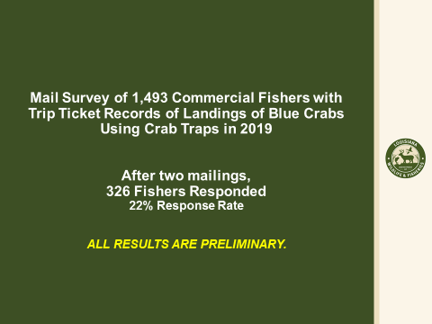
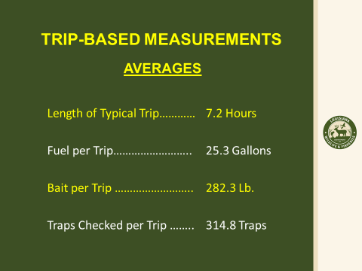
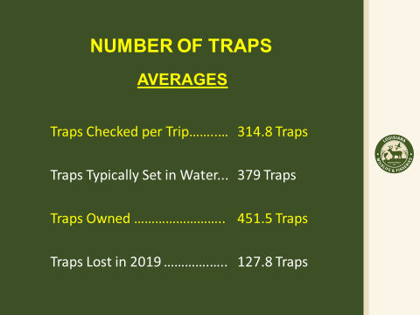
D. The task force made recommendations to fill CTF hard crab fishermen seat vacancies
Joey Edgar and Thanh Nguyen were both suggested to fill the CTF seat vacancies for commercial hard crab fishermen
VII. Public Comment
Michaela Myers provided a presentation on trip ticket reporting in crab markets
Acceptable Crab Markets to be Reported on Trip Tickets:
1 | Number 1 (Large crabs)
2 | Number 2 (Medium crabs)
3 | Number 3 (Small crabs)
4 | Factorzy Grade Crab
1 – 4 | Straight Run (Not graded)
11 | Female Crab
12 | Male Crab
13 | Crab Claws
14 | Buster or Peeler
15 | Softshell
VIII. Next meeting set for Tuesday, January 12, 2021 1:00pm at the St. Bernard Port.
Meeting adjourned

